Tableau Project Solutions

This information relates to pathology labs located in all US locations. In order to make a strategic and well-informed decision on its expansion, it must closely examine its past performance and business cycle. The management wishes to complete this task, including the analysis, forecasting, and pattern-finding.

Pathology Lab Center Data

Sample data preview

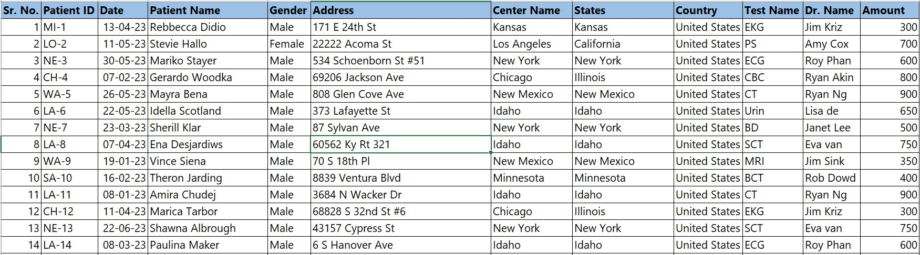

**Visual Insights**

* 1. Make a table listing the patients by month.

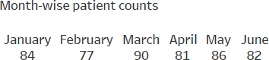

# Like:

***Step 1:*** *Drag the Date field into the Text*

***Step 2:*** *Drag the Patient Name field into the Text*

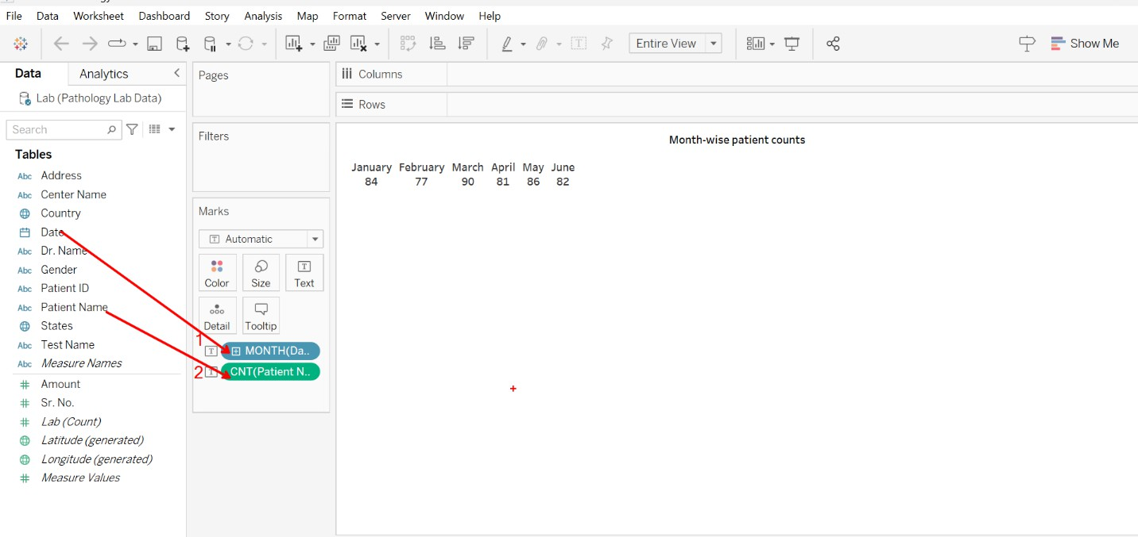

* 1. Make cards that include the overall cost as well as the number of patients.

# Like:



Drag the field “Patient Name” into the text (Marks cards)

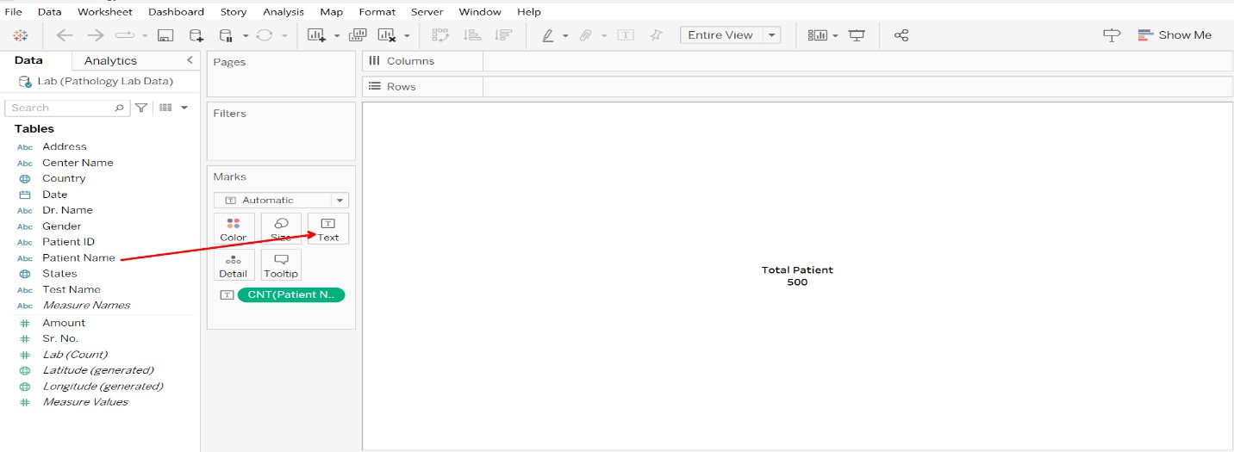

* 1. Make a table with the total number of patients and total amounts broken down by gender.

# Like:

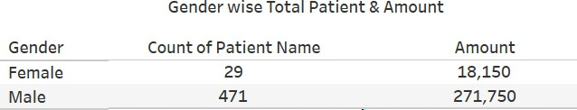

***Step 1****: Drag the field Patient Name into the Text*

***Step 2****: Drag the field Amount into the Text*

***Step 3****: Click on “Show Me”,* ***Step 4****: Select the table*

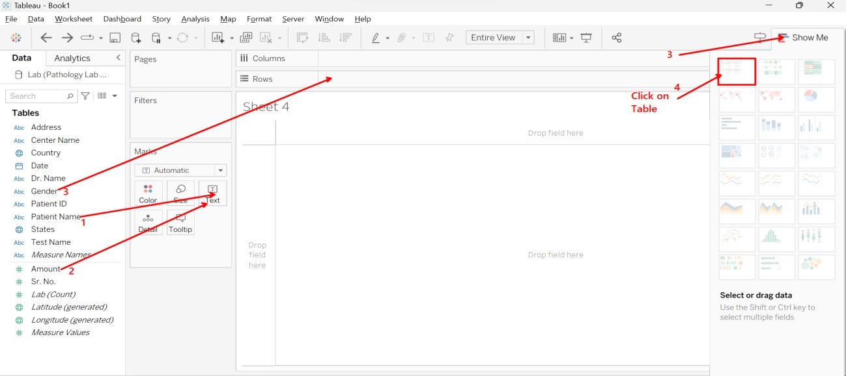

* 1. For each test name, total patients, and total amount create a column vs line chart.

# Like:

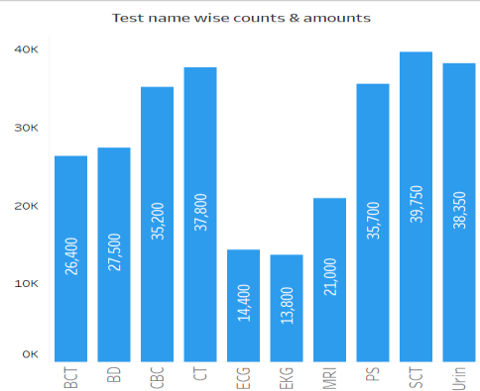

***Step1:*** *Drag the field Test Name into the column area*

***Step2:*** *Drag the field Amount into the row area*

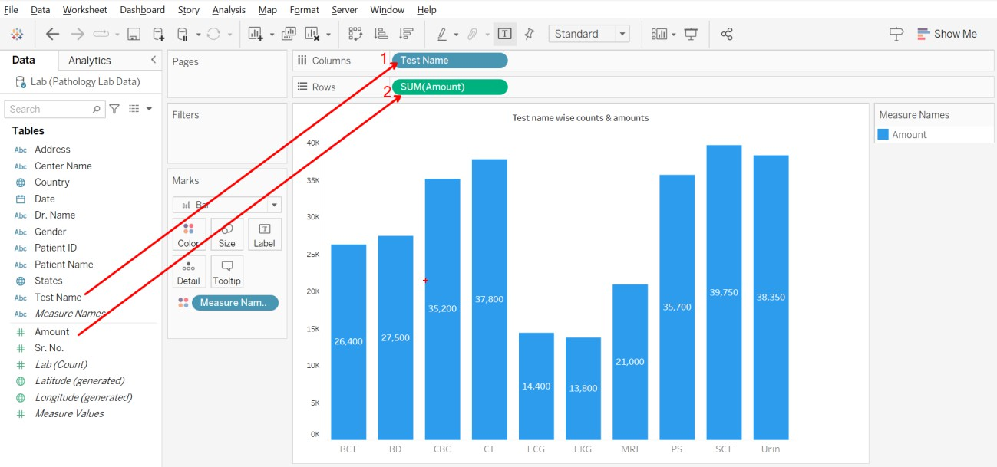

* 1. Create a table showing the overall number of patients and total amounts by doctor.

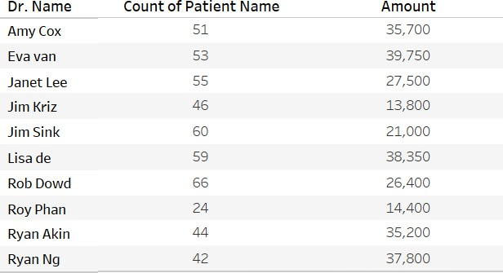

# Like:

***Step1****: Drag the Dr. Name field into the Rows area*

***Step2****: Drag the Patient name field into the text*

***Step3****: Drag the Amount field into the text*

***Step4****: Click on “Show me”*

***Step5****: Select “Table”*

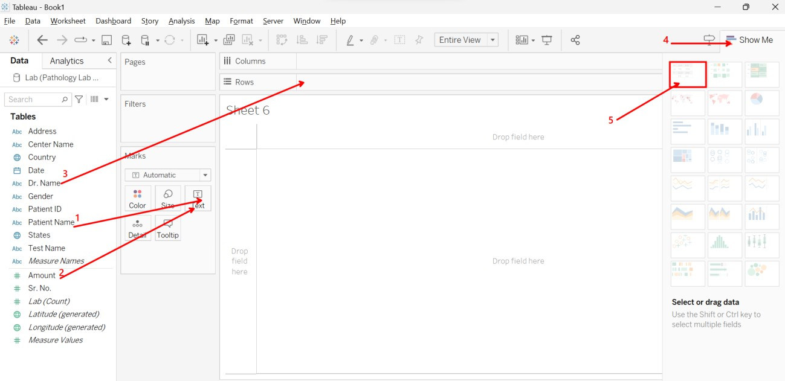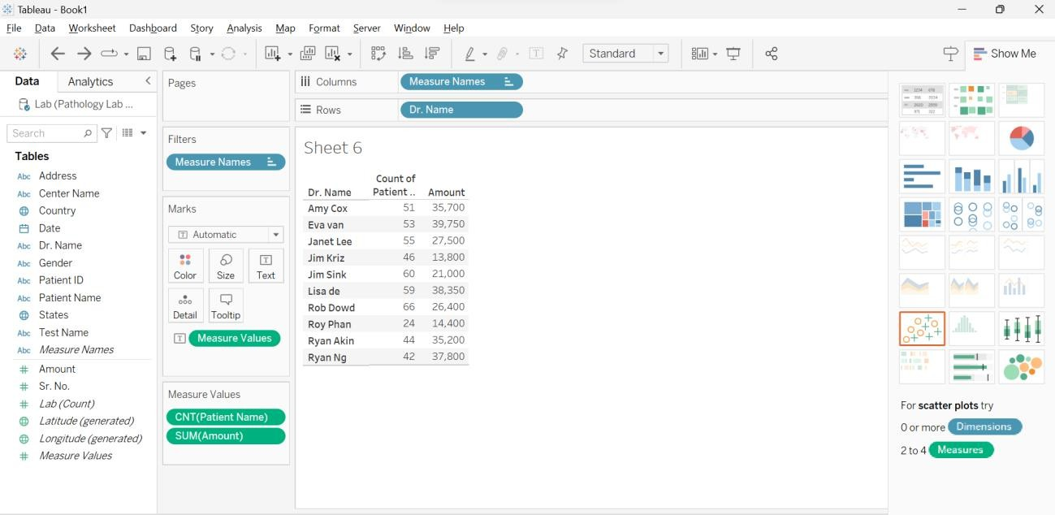

* 1. Create a map chart for state-wise total patients and the total amount

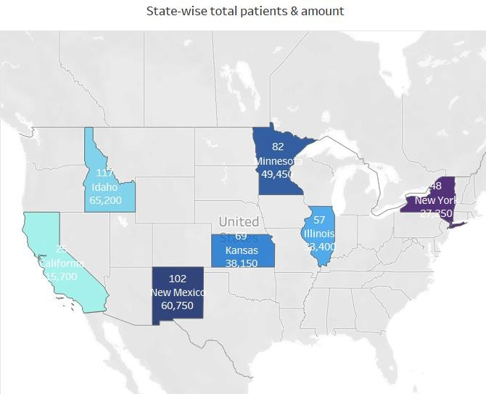

# Like:

***Step1****: Select the Field “Country”*

***Step2****: Ctrl-Click and Select Field “Amount”*

***Step3****: Click on Show Me and Select Map*

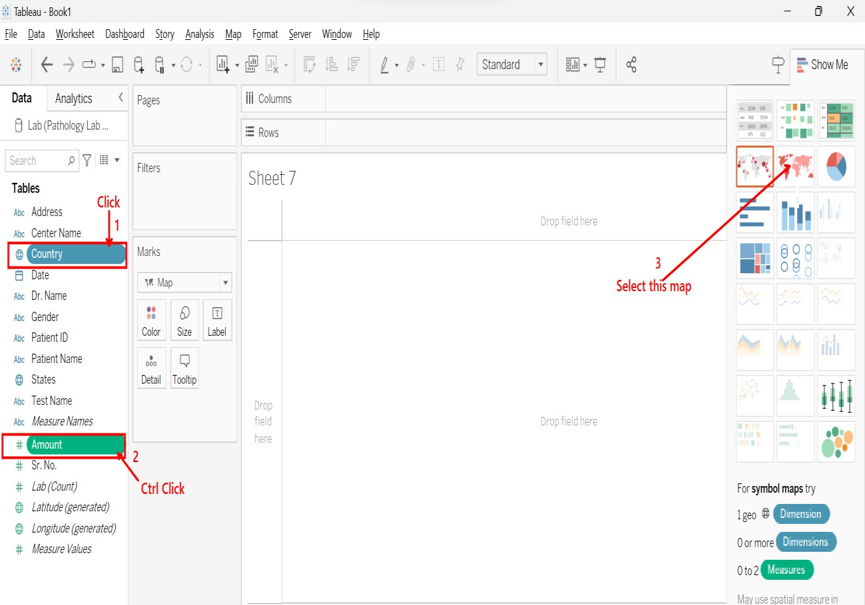

***Output is like below***

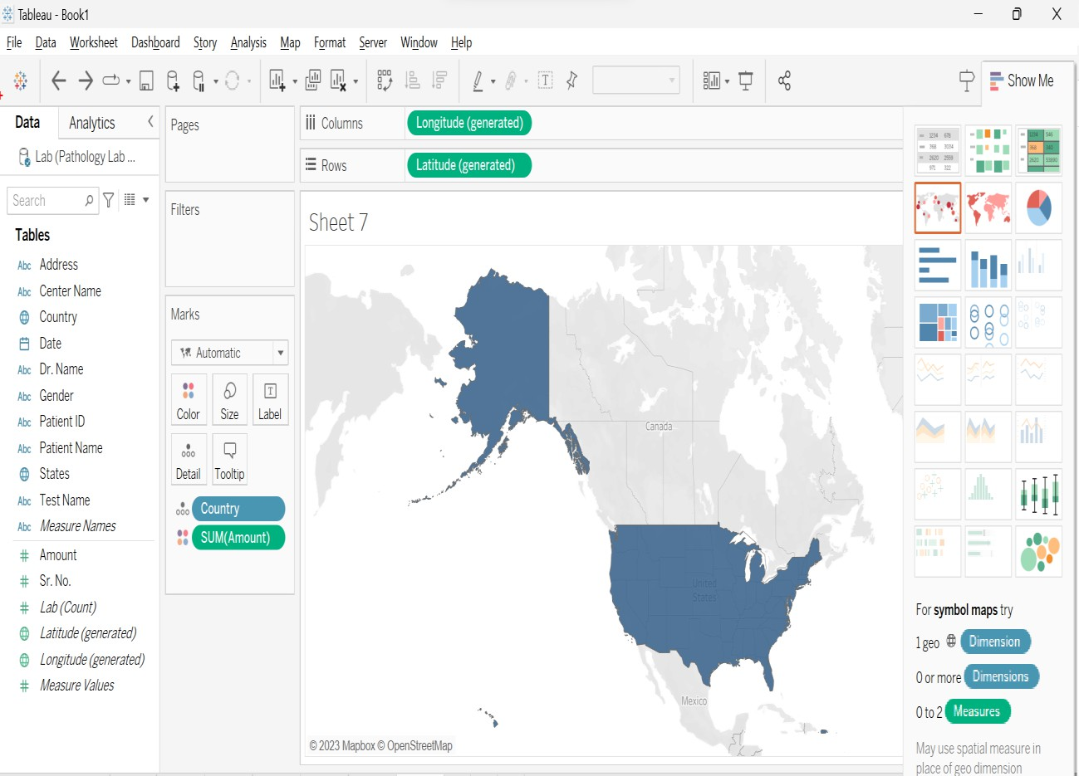

***Step1:*** *Drag the field States in the Color cards*

***Step2:*** *Then click on Map*

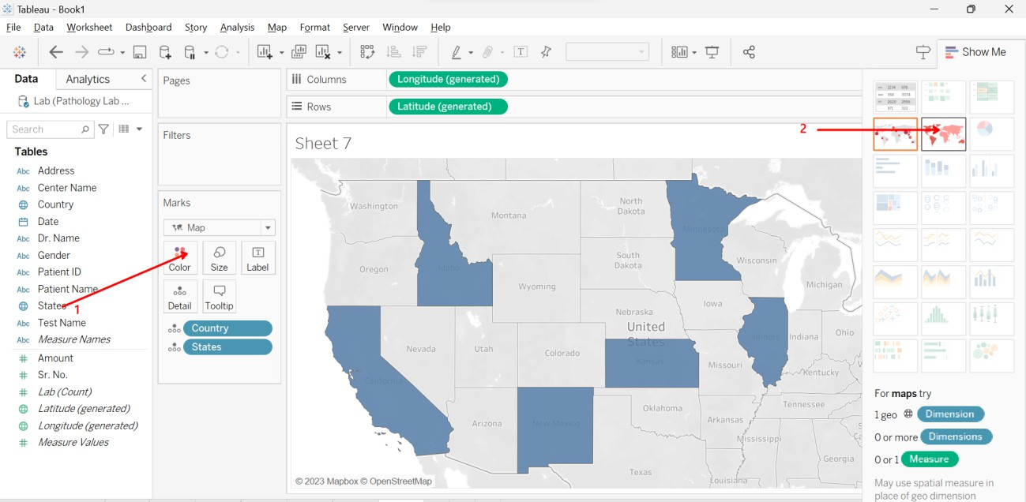

***Step 1 & 2:*** *Drag the field States into Color Cards and Drag into Label cards*

***Step 3:*** *Drag the field Patient Name into the Label*

***Step 3:*** *Drag the field Amount field into the Label*

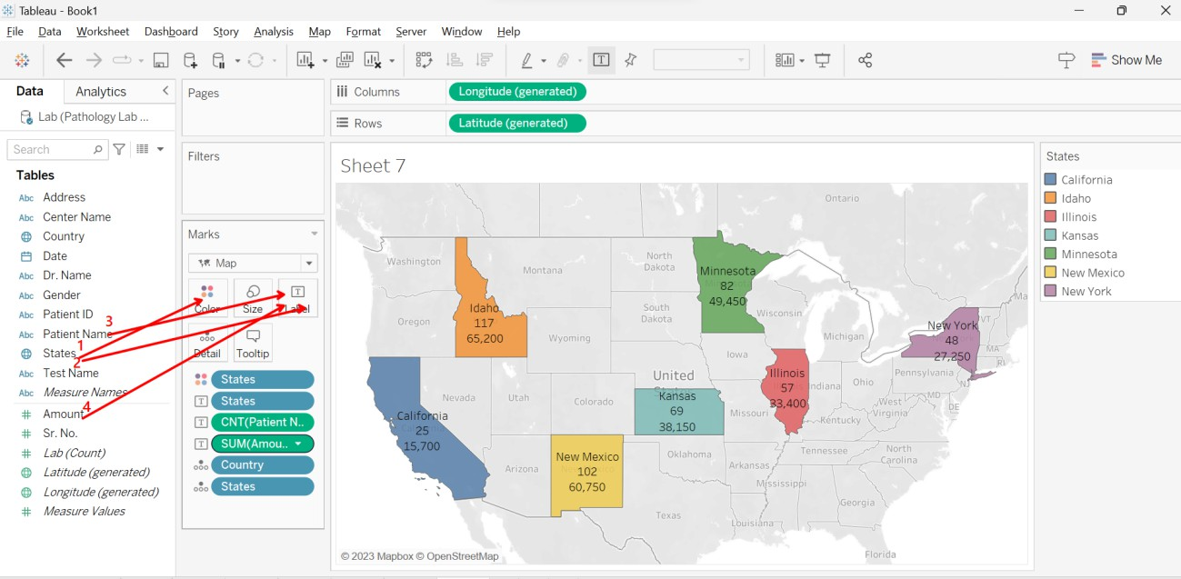

* 1. Create a Pie Chart for Gender wise Patient Count and Amounts

# Like

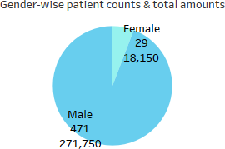

**Step 1**: Click on the field Gender then Ctrl-Click and Select the field Amount

**Step 2:** then select Pie Chart from show me

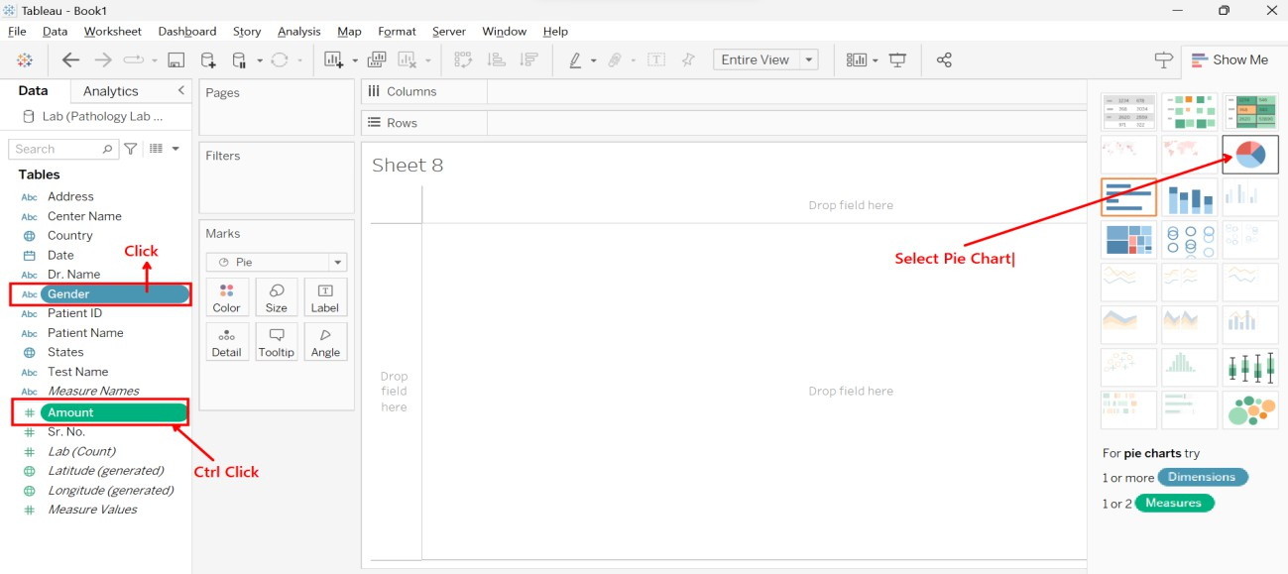

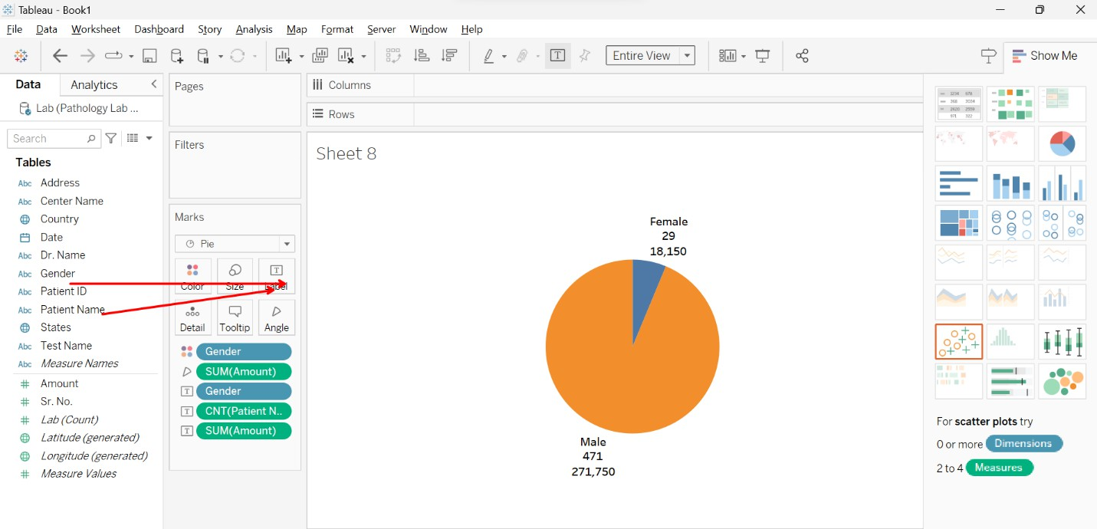Drag the Gender field and Patient field into the label cards.

**Final Dashboard**

